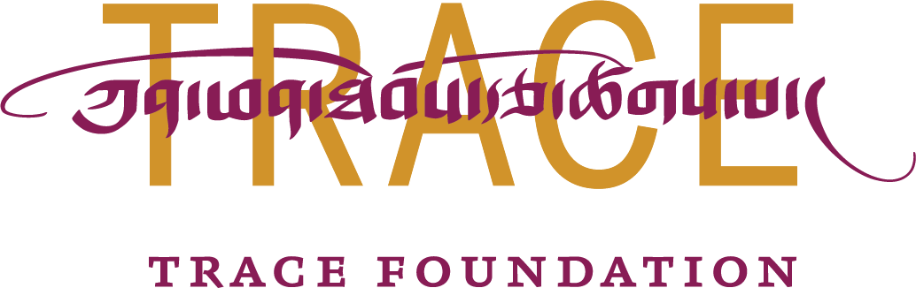
FOR IMMEDIATE RELEASE

TWO UNIQUE SHOWCASES OF CONTEMPORARY TIBETAN ART
Trace Foundation Celebrates Its Twentieth Anniversary

West Village, New York, New York, October 8, 2014—Trace Foundation is pleased to announce two art exhibitions to take place over the course of late 2014 and early 2015 in New York City, featuring contemporary Tibetan art and celebrating its twentieth anniversary of work with Tibetan communities. These exhibitions come on the heels of a popular film series, Lens on Tibet, which Trace produced at and in collaboration with The Museum of Modern Art (MoMA) in August 2014 as part of its larger anniversary celebration, “Gatön” (from the Tibetan word for “celebration”).

What does it mean to be Tibetan today? For a culture as diverse and dispersed as any on the planet, this is no easy question. Over the past few decades, Tibetan artists have been exploring their own answers, breaking radical ground. Trace Foundation has been there with them from the beginning—at the forefront of a new art scene, proudly supporting these emerging artists with grants and scholarships. Now, we invite you to join us for a glimpse into Tibet through the eyes, instruments, and the hands of artists living through this critical time in history.

November 6–December 4, 2014
TRANSCENDING TIBET PREVIEW EXHIBITION
This contemporary Tibetan art exhibition will feature eleven of the artists participating in the larger spring exhibition (all preview pieces will be different from the full exhibition). Traveling from Nepal, Italy, Switzerland, Amsterdam, and Queens, these artists will join us for an opening reception and roundtable discussion on everything from their unconventional choices of materials (silkscreen appliqué collage, incense-burned rice paper, monastic robes, and much more) to negotiating Tibet's rich legacy of traditional art and a fast-changing world.

  - November 6, 2014, 6:30–8:30 pm: Opening reception.
  - November 12, 2014, 6:30–8:30 pm: Contemporary Tibetan art scholar Leigh Miller in conversation with the artists.
  - December 4, 2014, 6:30–8:30 pm: Paperback launch of Clare Harris's book The Museum on the Roof of the World: Art, Politics, and the Representation of Tibet and discussion with renowned contemporary Tibetan artists Gonkar Gyatso and Tenzing Rigdol.

Participating artists: Kesang Lamdark, Livia Liverani*, Michela Martello*, Nyima Dhondup*, Rabkar Wangchuk*, Sonam Dolma Brauen*, Tashi Norbu (Amsterdam)*, Tashi Norbu (Lhasa), Tenzin Phakmo*, TseKal, and Tülkü Jamyang*. (Asterisks denote the artists will attend the opening reception and November 12 talk.)

The preview exhibition will be open to the public Tuesdays through Saturdays, 10am–5pm, November 7 through December 4 (closed November 27 through November 29 for the Thanksgiving holiday). The opening reception and exhibition will take place in the ground-floor gallery space at 132 Perry Street. The two talks will take place in Suite 2B, in Trace Foundation’s library.

Spring 2015 (dates to follow)
TRANSCENDING TIBET FULL EXHIBITION
Timed to coincide with Asia Art Week 2015, this contemporary Tibetan art exhibition will feature the new commissioned works of 30 artists. As with the preview, the full exhibition will be accompanied by an opening reception and a number of talks with the artists.

Once limited to religious thangkas and landscapes meant for tourists, Tibetan visual art has in just ten years transformed into a flourishing international movement. The first of its kind in the West, Transcending Tibet will feature new commissioned artworks by twenty-six contemporary Tibetan artists, alongside four Western artists whose work incorporates Tibetan themes. The exhibition will provide a rare opportunity for wide audiences to experience the new artistic forms emerging from the Tibetan Plateau. The exhibition will be on view for six weeks and will be accompanied by a full-color catalog, with contributions by Tibetan art scholars Leigh Miller and Martin Brauen and artists Gade and Benchung.

For both exhibitions, the participating artists represent a wide array of points in their careers, from emerging to established. Though most of these artists share a Tibetan heritage, their diverse upbringings have resulted in artworks that appropriate iconography from historic Tibetan art as well as from other cultures throughout the world. One artist, Gade, is known for inserting icons such as Mickey Mouse, Ronald McDonald, and Spiderman where the Buddha once was in pieces that otherwise embrace the tone and feel of traditional Tibetan art. Other artists are using Western materials to address religious and social issues in Tibet, such as Kesang Lamdark, who often uses spray paint, soda cans, melted plastic, tequila bottles, and disco music in his work. Artists Gonkar Gyatso and Tenzing Rigdol have recently been featured at the Metropolitan Museum of Art.

Participating artists (as of October 8, 2014): Benchung, Ga Qin, Gade, Gonkar Gyatso, Jhamsang, Kesang Lamdark, Livia Liverani, Losang Gyatso, Michela Martello, Mirella Virgili, Nortse, Nyima Dhondup, Pema Rinzin, Pempa, Phuntsok Tsering, Rabkar Wangchuk, Rima Fujita, Sodhon, Sonam Dolma Brauen, Tashi Norbu (Amsterdam), Tashi Norbu (Lhasa), Tashi Phuntsok, Tenzin Norbu, Tenzin Phakmo, Tenzing Rigdol, TseKal, Tserang Dhondup, Tseren Dolma, Tsering Nyandak, and Tülkü Jamyang.

The exhibition venue will be announced soon. Talks will take place at Trace Foundation, 132 Perry Street, Suite 2B, New York, NY 10014. Further details and sample images are available at http://gaton.trace.org/

Transcending Tibet is organized by Paola Vanzo, Director of Communications and Development, and Kristina Dy-Liacco, Librarian of Trace Foundation, with artistic direction by Davide Quadrio of Arthbub Asia and support from an anniversary advisory board whose members to date include Chris Anderson, TED; Sally Berger, MoMA; Professor Dr. Martin Brauen, Chief Curator Emeritus, Rubin Museum of Art; Lois Conner, photographer; Jacqueline Dennis, Sotheby’s; Silvia Negri Firman, Negri Firman PR & Communication; Gade, artist; Joshua Liner, Joshua Liner Gallery; William Lipton, William Lipton, Ltd., Kesang Namgyal; Kate and Bob Niehaus; Jacqueline Novogratz, Acumen Fund; Andrew Quintman, Yale University; Tenzing Rigdol, artist; Jonathan and Diana Rose, the Garrison Institute; Orville Schell, the Center on U.S.-China Relations at the Asia Society; Tsering Shakya, Institute of Asian Research at the University of British Columbia; Elizabeth Sheldon, Alive Mind Cinema; Robert Soros, Soros Fund Management; Pema Tseden, filmmaker; Gray Tuttle, Columbia University; Darren Walker, the Ford Foundation; Miho Walsh, Asian Cultural Council; Susan Weber, Bard Graduate Center; and Karen Yager, Karen Yager Fine Art Conservation.

Gatön is presented in partnership with MoMA and with the support of the Ellen Bayard Weedon Foundation, Enterprise Foundation, the Ford Foundation, the Gilbert Family Trust, and Kathleen C. Xi.

For high-resolution images, photos, and interview opportunities, contact:
Johnathan Wilber; jwilber@trace.org or 212-367-7380, x 16

For twenty years, Trace Foundation has supported the continuity, development, and vitality of Tibetan communities. We work to better people's lives and reinforce the uniqueness of Tibetan culture, language and places. Through our work in Community Development, Scholarships, Contemporary Culture & Heritage Preservation, and Research & Documentation we're making a difference for the future of Tibetan communities. Events at Trace Foundation seek to increase awareness of and appreciation for Tibetan culture. The Foundation is headquartered in New York City.
Trace Foundation’s Latse Library was established in 2003 as a project of the Foundation with the aim of furthering its mission of promoting the cultural continuity and sustainable development of Tibetan communities within China. Latse’s extensive and diverse collection of thangka, pecha, books, journals, and non-print materials offers a rare glimpse into the myriad forms of contemporary Tibetan culture.

132 Perry Street, 2B, New York, NY | www.gaton.trace.org | www.facebook.com/tracefoundation
###

